Alenne Jasper Cañete

BSIT – 3rd Year

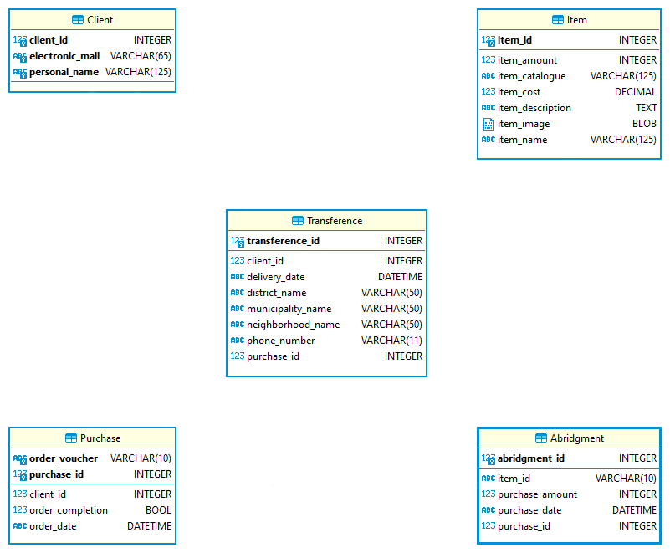­

1..1

**mails**

1..1

1..1

1..1

**creates**

1..1

1..1

0..*

**chooses**

1..1

**places**

1..1

**calculates**

0..*

E – Commerce Information System

Entity – Relationship Diagram